**Тренажёр для подготовки к выполнению задания 4 устной части ЕГЭ по английскому языку в 2022 году**

Автор: Елена Викторовна Астафьева, учитель МБОУ «Гимназия № 4» г. Смоленска

Задание 4 устной части ЕГЭ по английскому языку представляет собой связное тематическое монологическое высказывание с элементами рассуждения (обоснование выбора иллюстраций к предложенной теме проектной работы и выражение собственного мнения по теме проекта). В связи с изменениями, внесёнными в план задания № 4 в ноябре 2021 года, у учащихся возникают вопросы, что и как необходимо сказать в ответе. Перед выполнением задания необходимо ознакомиться с демоверсией устной части ЕГЭ-2022 и внимательно изучить критерии оценивания ответа, за который можно получить максимум 10 баллов (см. сайт ФИПИ <https://fipi.ru/ege/demoversii-specifikacii-kodifikatory#!/tab/151883967-11>).

В данной статье предлагаю свои варианты клише, которые можно использовать при составлении монологического высказывания. Следует учесть, что фразы, выделенные *курсивом*, на экзамене будут заменены на аналогичные, в зависимости от темы задания.

|  |  |
| --- | --- |
| ***План высказывания*** | ***Клише*** |
| **Introduction** | Hello, Ann! I`ve found a couple of photos for our project «…» and I`d like to comment on them. |
| **1)** **give a brief description of the photos, justifying the choice of the photos for the project;** | I think these photos illustrate the project very well because they show 2 completely different types of … .  In the first picture, there is a … *or* I can see… (what/who/where) *or* The first photo shows ….  In the second picture, there is a … (what/who/where). |
| **2) say in what way the pictures are different, justifying the choice of the photos for the project;** | As you can see, there are some apparent differences between the photos.   The first picture shows …, while in the second one the girl/the man *is using/doing/looking* etc.  Besides, the *girl/boy/student* in picture 1 … , but the *woman/teacher/doctor* in the second picture … . |
| **3) mention the advantages and disadvantages (1–2) of the two options;** | In my opinion, both types of … have their pros and cons. The main advantage of … is that … . On the other hand, … . As for …, one of the advantages is that … . However, … . |
| **4) express your opinion on the subject of the project – *whether you would like to live without gadgets and why/whether you prefer online education or not, and why etc.*** | As for me, *I would like to/I wouldn’t like to … /I prefer* … because (as) … . |
| **Conclusion** | Well, that`s all for now. Hope you`ll like the photos. Call me back or send a message when you can. |

**Образец ответа (тема проекта “Life without gadgets”, демоверсия 2022 г.)**

*Hello, Ann! I`ve found a couple of photos to illustrate our project “Life without gadgets” and I`d like to comment on them.*

*I think these photos illustrate the project very well because they show two completely different types of books. In the first picture, there is a girl reading quite a thick book in the library. In the second picture, there is a girl sitting on the sofa and holding an e-book in her hands.*

*As you can see, there are some apparent differences between the photos. The first picture shows the girl who seems to be preparing for her exams and is reading ordinary books, while in the second photo the girl is using an electronic device. Maybe she is reading for pleasure as she looks happy. Besides, the student in picture 1 is surrounded by other people in the library, while the girl in picture 2 is sitting at home alone and no one can disturb her.*

*In my opinion, both types of books have their pros and cons. The main advantage of a paper book is that your eyes don`t hurt after using it for a long time. On the other hand, paper boos have a great disadvantage - they cost a lot nowadays and going to the library takes lots of time. As for e-books, one of the advantages is that you can store as many novels as you want in your device and read them whenever you want. However, this gadget has a disadvantage – eyes get tired because the size of the book is usually quite small and you have to flip pages quickly.*

*As for me, I wouldn`t like to live without gadgets. I think various devices make our life simpler, more comfortable and save a lot of time.*

*Well, that`s all for now. Hope you`ll like the photos. Call me back or send a message when you can.*

Для подготовки к заданию 4 устной части экзамена предлагаю использовать задания тренажёра (см. Приложение). Учащиеся могут рассказать монологи учителю в классе или воспользоваться онлайн-тренажёром на платформе Online Test Pad дома и прислать аудиозапись учителю на проверку. Ссылка на онлайн-тренажёр (предусмотрена голосовая запись): <https://onlinetestpad.com/2jn7wozvq6x5m>. Кодовое слово: English.

Список использованных источников

* Веселова, ЮС. Английский язык. Единый Государственный Экзамен. Готовимся к итоговой аттестации: [учебное пособие]/ЮС. Веселова. – Москва: Издательство «Интеллект-Центр», 2022. – 176 с.
* СДАМ ГИА: РЕШУ ЕГЭ. Образовательный портал для подготовки к экзаменам [Электронный ресурс]/свободный доступ. – Режим доступа: URL: <https://en-ege.sdamgia.ru/test?theme=56>
* Демоверсии, спецификации, кодификаторы [Электронный ресурс]/свободный доступ. – Режим доступа: URL: <https://fipi.ru/ege/demoversii-specifikacii-kodifikatory#!/tab/151883967-11>
* Фотографии [Электронный ресурс]/свободный доступ. – Режим доступа: URL: <https://yandex.ru/images/search?text=zyltrc%20rfhnbyrb&lr=12>

**Приложение**

**Тренажёр для подготовки к выполнению задания 4 устной части ЕГЭ по английскому языку в 2022 году**

**Вариант 1.**

Imagine that you are you doing a project “Online Education” together with your friend. You have found some illustrations and want to share the news. Leave a voice message to your friend. In 2.5 minutes be ready to:

* give a brief description of the photos, justifying the choice of the photos for the project;
* say in what way the pictures are different, justifying the choice of the photos for the project;
* mention the advantages and disadvantages (1–2) of the two options;
* express your opinion on the subject of the project – whether you would like to study online or offline, and why.

You will speak for not more than **3 minutes (12–15 sentences).** You have to **talk continuously**.

Photo 1 Photo 2

 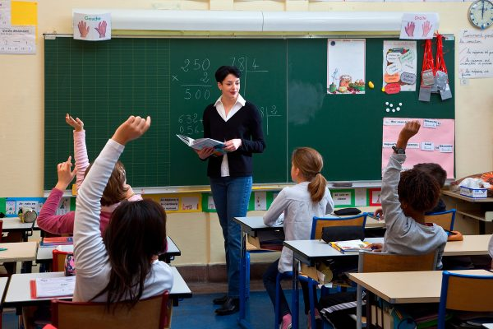

**Вариант 2.**

Imagine that you are you doing a project “The best means of travelling” together with your friend. You have found some illustrations and want to share the news. Leave a voice message to your friend. In 2.5 minutes be ready to:

* give a brief description of the photos, justifying the choice of the photos for the project;
* say in what way the pictures are different, justifying the choice of the photos for the project;
* mention the advantages and disadvantages (1–2) of the two options;
* express your opinion on the subject of the project – whether you prefer to travel by bike or plane, and why.

You will speak for not more than **3 minutes (12–15 sentences).** You have to **talk continuously.**

Photo 1 Photo 2

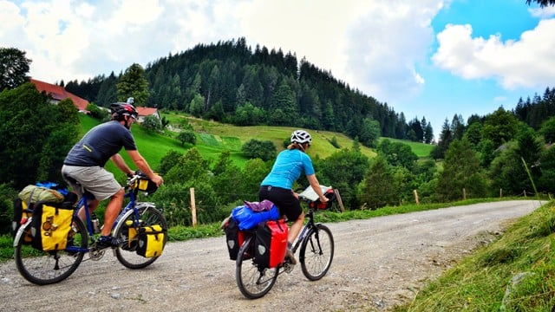 

**Вариант 3.**

Imagine that you are you doing a project “Popular Pets” together with your friend. You have found some illustrations and want to share the news. Leave a voice message to your friend. In 2.5 minutes be ready to:

* give a brief description of the photos, justifying the choice of the photos for the project;
* say in what way the pictures are different, justifying the choice of the photos for the project;
* mention the advantages and disadvantages (1–2) of the two options;
* express your opinion on the subject of the project – whether you would prefer to have some fish or a dog, and why.

You will speak for not more than **3 minutes (12–15 sentences).** You have to **talk continuously**.

Photo 1 Photo 2

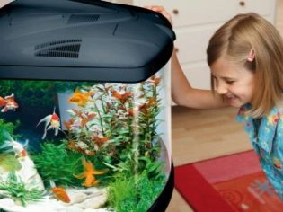 

**Вариант 4.**

Imagine that you are you doing a project “Kinds of sport” together with your friend. You have found some illustrations and want to share the news. Leave a voice message to your friend. In 2.5 minutes be ready to:

* give a brief description of the photos, justifying the choice of the photos for the project;
* say in what way the pictures are different, justifying the choice of the photos for the project;
* mention the advantages and disadvantages (1–2) of the two options;
* express your opinion on the subject of the project – what kind of sport you would prefer, and why.

You will speak for not more than **3 minutes (12–15 sentences).** You have **to talk continuously**.

Photo 1 Photo 2

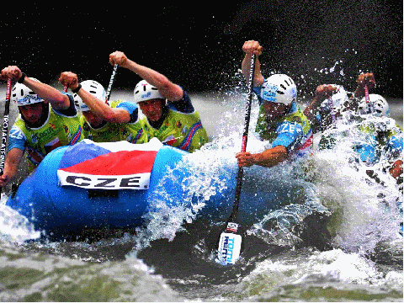 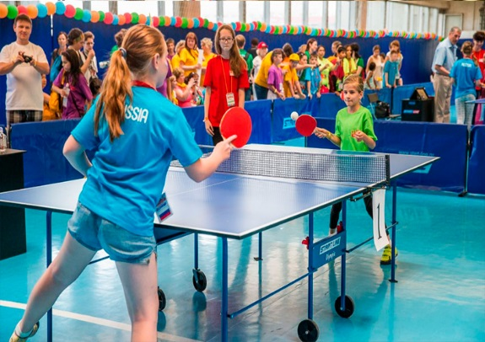

**Вариант 5.**

Imagine that you are you doing a project “Volunteering” together with your friend. You have found some illustrations and want to share the news. Leave a voice message to your friend. In 2.5 minutes be ready to:

* give a brief description of the photos, justifying the choice of the photos for the project;
* say in what way the pictures are different, justifying the choice of the photos for the project;
* mention the advantages and disadvantages (1–2) of the two options;
* express your opinion on the subject of the project – whether you would like to be a volunteer or not, and why.

You will speak for not more than **3 minutes (12–15 sentences).** You have to **talk continuously.**

Photo 1 Photo 2

