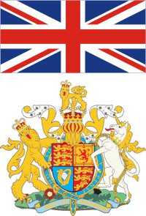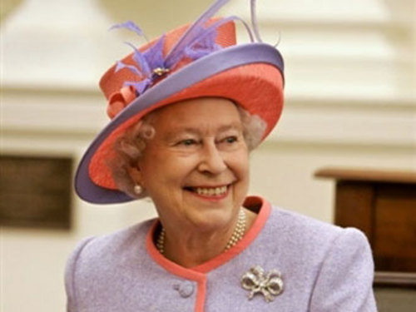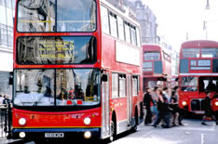
YOUR OWN GAME
Страноведческая игра
Соединенное Королевство Великобритании и Северной Ирландии

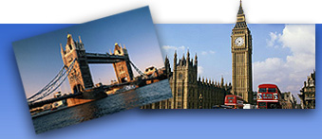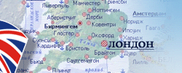



Целевая аудитория: обучающиеся 5-9 классов
Область использования материала: внеклассная работа по английскому языку, неделя иностранных языков в школе
Форма работы: командное соревнование
Оборудование: карточки с вопросами, мультимедийная презентация
Цели мероприятия:
- развитие социокультурной компетенции учащихся
- формирование общекультурной идентичности личности
- расширение общекультурного кругозора
Задачи:
- проверить свои страноведческие знания о Соединенном Королевстве по следующим категориям:
- символы;
- карта;
- известные города;
- традиции, праздники;
- литература;
- известные люди;
- Лондон
- познакомиться с национально-культурными особенностями страны изучаемого языка;
- получить представление об особенностях образа жизни, быта, культурных традициях и праздниках страны изучаемого языка
- расширить знания об известных культурных достопримечательностях, городах и географических объектах, литературных произведениях, выдающихся людях и их вкладе в мировую культуру

Категории вопросов:
Symbols
Map
Cities
Traditions, celebrations
Literature
Famous people
London

I. Symbols
1. What flower is the national emblem of England?
2. How is the flag of the UK called?
3. What country is the green colour symbolic for?
4. What animal is shown on the flag of Wales?
5. What two animals are shown on the UK coat of arms?
6. What flower is the national emblem of Scotland?
II. Map
1. How many parts does the UK consist of?
2. What river is London situated on?
3. What is the name of the mysterious lake in the UK?
4. What is the name of the Isles, where the UK is situated?
5. What is the highest mountain in the UK?
6. What channel separates the UK and France?
III. Cities
1. What is the capital of Scotland?
2. What city is the birthplace of the famous musical band “the Beatles”?
3. What city is famous for its big tennis competition?
4. What city is the famous British football team named after?
5. What two English cities are university cities?
6. What is the hometown of the national English hero Robin Hood?
IV. Traditions, celebrations
1. How many floors are there in a typical English traditional house?
2. What holiday is celebrated on the 31st of October?
3. What is the traditional musical instrument of Scotland?
4. What holiday is celebrated on the 5th of November?
5. What traditional dishes are there on Christmas?
6. What time of the day do the British have the traditional tea-break at?
V. Literature
1. Shakespeare wrote plays for the theatre called…
2. What English writer was called “The Queen of Crime”?
3. What English writer wrote the novel “Robinson Crusoe”?
4. Who wrote two books about the adventures of Tom Sawyer?
5. What is the name of the most famous Scottish poet?
6. Who is the author of the books about Harry Potter?
VI. Famous people
1. Who is the most famous English footballer?
2. Who invented the first telephone?
3. What is the name of the most popular English princess?
4. What is the surname of two brothers invented the first aeroplane?
5. Who was the prime-minister of the UK during the World War II?
6. What architect designed St. Paul`s Cathedral?
VII. London

Look through the presentation about London and write down its landmarks
1,2,3,4,5,6,7,8,9,10,11,12,13,14,15,16,17,18,19
Keys:
Symbols (red sheet)
1. Red rose
2. Union Jack
3. Ireland, Nothern Ireland
4. Red dragon
5. A lion, a unicorn
6. Thistle
Map (green sheet)
1. Four
2. The Thames
3. The Loch Ness
4. The British Isles
5. Ben Nevis
6. The English Channel
Cities (yellow sheet)
1. Edinburgh
2. Liverpool
3. Wimbledon
4. Manchester
5. Oxford, Cambridge
6. Birmingham
Traditions, celebrations (blue sheet)
1. Two
2. Halloween
3. Bagpipe
4. Guy Fawkes Night/Day
5. Turkey, pudding
6. At 5 o`clock
Literature (white sheet)
1. The Globe
2. Agatha Christie
3. Daniel Defoe
4. Mark Twain
5. Robert Burns
6. Joanne Rowling
Famous people (orange sheet)
1. David Beckham
2. Alexander Graham Bell
3. Diana
4. Wright
5. Sir Winston Churchill
6. Sir Christopher Wren
London
Keys to the presentation:

1.Trafalgar Square
2.The Houses of Parliament
3.Big Ben
4.Tower Bridge
5.The Tower of London
6.Buckingham Palace
7.Oxford Street
8.Greenwich Observatory
9.Madam Tussaud`s Museum
10.London Eye
11.Hyde Park
12. 10, Downing Street
13.Globe Theatre
14.Supermarket Harrods
15.Westminster Abbey
16.Margaret Thatcher, Prince Charles, Prince William, David Cameron
17.Conan Doyle
18.Charles Dickens
19.Millenium Bridge

Список использованной литературы:
- Baranovsky L.S., Kozikis D.D. Panorama of Great Britain. Mn, 1990.
- Baranovsky L.S., Kozikis D.D. How do you do, Britain. Mn, 1996.
- Ощепкова В.В., Шустилова И.И. “Britain in brief” Москва «Лист»
- Britain 2000 Year Book. HMSO. London, 2000.
- Champion A.G., Townsend A.K. Contemporary Britain. London, 1990.
- Harvery P. The Oxford Companion to English Literature. Oxford, 1990.
- Kearney H.A. History of Four Nations. Cambridge, 1992.
- Khimunina T., Konon N., Waishe I. Customs, Traditions and Festivals of Great Britain. L., 1975
- King W.J. The British Isles. London, 1976.
- Porey J., Waishe I. An English Teacher’s Handbook of Educational Terms. M., 1982
- Room A. An A to Z of British Life. Dictionary of Britain. – Oxford, 1990.
- Пособие по страноведению. М., 1998. Великобритания. Лингвострановедческий словарь. М.,1978.
- Кгртман Л.Е. География, история и культура Англии. М., 1979.
- Польская Н.М. Великобритания. М., 1986.

